**Lab Report -01**

**\*\*How to install Linux operating system..**

**(i).What is Linux operation system??**

**Linux operating system :**

Linux® is an [open source](https://www.redhat.com/en/topics/open-source/what-is-open-source) operating system (OS). An [operating system](https://www.redhat.com/en/technologies/linux-platforms/old-enterprise-linux) is the software that directly manages a system’s hardware and resources, like CPU, memory, and [storage](https://www.redhat.com/en/topics/data-storage/software-defined-storage). The OS sits between applications and hardware and makes the connections between all of your software and the physical resources that do the work.

Think about an OS like a car engine. An engine can run on its own, but it becomes a functional car when it’s connected with a transmission, axles, and wheels. Without the engine running properly, the rest of the car won’t work.

**(ii).Difference type of Linux Distributions:**

**1. Ubuntu**

Yes, Ubuntu has become the poster child for Linux these days, and no wonder--it's the most popular distro by far, garnering more than 2,200 hits per day on the Distrowatch site alone, compared with some 1,400 for Fedora, the No. 2 contender.

Ubuntu is actually a relatively late arrival on the Linux scene, having been announced in just 2004, but it's more than made up for that shorter history. Founded by South African millionaire Mark Shuttleworth, Canonical--the company behind Ubuntu--for many years shipped Ubuntu CDs to interested users for free, thus speeding its market penetration.

Ubuntu is based on Debian (see below) and includes well-known apps such as [Firefox](https://www.pcworld.com/businesscenter/article/204120/firefox_4_browser_inches_ahead_with_ease_of_use.html) and [OpenOffice.org](https://www.pcworld.com/businesscenter/article/203910/dont_count_on_oracle_to_keep_openofficeorg_alive.html). It has a predictable, six-month release schedule, with occasional Long Term Support (LTS) versions that are supported with security updates for three to five years.

Ubuntu is also notable for its ease of use and its inclusion of a migration assistant for Windows users and support for the latest technologies. Version 10.10 of Ubuntu--also known as [Maverick Meerkat](https://www.pcworld.com/businesscenter/article/204225/what_will_ubuntu_1010_look_like.html)--will include a multitouch and gesture stack. The final iteration of that version is due out next month.

It's also worth understanding that Ubuntu is available in various remixes and spin-off sub-distros targeted at specific niches, such as Kubuntu, Xubuntu and Lubuntu. Most of these differ primarily by offering a desktop environment other than Ubuntu's standard [GNOME](http://www.gnome.org/).

**2. Fedora**

Fedora is the free version of Red Hat, whose RHEL ([Red Hat Enterprise Linux](https://www.pcworld.com/businesscenter/article/192929/red_hat_focuses_new_rhel_55_on_multicore.html)) has been a commercial product since 2003. Because of that close connection, Fedora is particularly strong on enterprise features, and it often offers them before RHEL does.

Fedora also offers a six-month release schedule, and its [security features](https://www.pcworld.com/businesscenter/article/202452/why_linux_is_more_secure_than_windows.html) are excellent. While some have viewed it as a cutting-edge distro for the Linux "hobbyist," I think improvements over the years and widespread popularity have combined to make it a good choice for newer Linux users as well.

**3. Linux Mint**

Currently in Distrowatch's third spot in popularity, Linux Mint is an Ubuntu-based distro that was just launched in 2006. The operating system adds to Ubuntu with its own, distinct desktop theme and a different set of applications; also unique to the distro are a variety of graphical tools for enhanced [usability](https://www.pcworld.com/businesscenter/article/202364/is_linux_really_harder_to_use.html), such as mintDesktop for configuring the desktop environment, mintInstall for easier software installation and mintMenu for easier navigation.

Mint enjoys a well-deserved reputation for ease of use, so it's another good one for beginning users. It also includes some proprietary multimedia codecs that are often absent from larger distributions, thereby enhancing its hardware compatibility. Mint doesn't have a fixed release schedule, but typically a new version comes out shortly after each stable Ubuntu release.

**4. openSUSE**

With some 1,200 hits per day on Distrowatch, openSUSE holds the No. 4 spot in popularity on the site and is also the foundation for Novell's SUSE Linux Enterprise Desktop and SUSE Linux Enterprise Server products.

The package's administration utility, YaST, is widely acknowledged as one of the best, and its boxed edition comes with some of the best printed documentation you'll find for any distro. I'd say openSUSE rates a "medium" on difficulty level.

**5. PCLinuxOS**

Rather than GNOME, PCLinuxOS uses the [KDE](http://www.kde.org/) desktop environment and is essentially a lighter-weight version of Mandriva (see below). With good support for graphics drivers, browser plugins and media codecs, PCLinuxOS can be a good choice for beginners. Its release cycle can be erratic, though, and there is also no 64-bit version of the software.

**6. Debian**

Dating back to 1993, Debian is currently known as one of the most well-tested and bug-free distros available today. Though it serves as the foundation for Ubuntu, most view Debian as a distro best-suited for those experienced with Linux. The distro uses all open-source components, which is a good thing, but means it can be more difficult to achieve compatibility with proprietary code such as wireless network drivers. Debian also has a relatively slow release cycle, with stable ones coming out every one to three years.

**7. Mandriva**

Formerly known as Mandrake, Mandriva is notable for its cutting-edge software, excellent administration suite and 64-bit edition. It was also the first major distribution to jump on the netbook bandwagon with out-of-the box support. Nevertheless, Mandriva has been struggling lately as a result of some controversial decisions made by its French maker. It recently restructured, with the result that some view the future of its community version as uncertain.

**8. Sabayon/Gentoo**

Italian Sabayon is essentially a LiveCD version of Gentoo, which is known for allowing users to individually optimize each component. Both are considered advanced Linux distributions aimed primarily at experienced users.

**9. Arch Linux... plus Slackware**

Arch is another package aimed primarily at experienced users interested in tweaking and optimizing their systems. Though not in the top 10 currently, Slackware is similarly oriented toward Linux gurus.

**10. Puppy Linux... plus DSL**

Last on Distrowatch's top 10 currently is Puppy Linux, a compact distro that's ideal for older hardware and situations where computing resources are minimal. (Damn Small Linux, incidentally, is similar.) Though it has a small footprint, Puppy is still full-featured and includes a variety of configuration and application installation wizards. The whole OS is small enough to run directly from system RAM, so applications start quickly and respond to user input instantly.

**(iii) How can we install Linux Operating System??**

**PART 1: GET PREPARED**

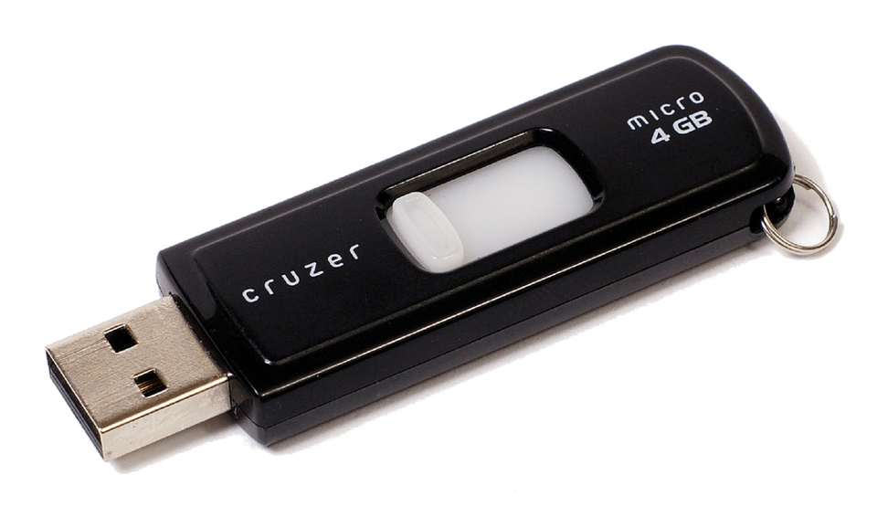

Yep, you can carry around a bootable,

persistent, modern OS on this.

 KINGSTON

Before we install Ubuntu, let's get everything prepped. I'm going to assume you're reading this guide from Windows. It's also assumed that you're using a 64-bit version of Windows; highly likely if you're using Windows 7, 8 or 10. (You can do Part 1 on a Mac, but I have less experience with Linux installs on Apple hardware so we'll stick to traditional PCs)

**Step 1: Evaluate Your Storage Space**

Let's not go into this blind. Put some thought into whether you want to completely wipe out Windows, or dual-boot with both Windows and Ubuntu. The installation you're about to do will give you full control to completely erase your hard drive, or be very specific about partitions and where to put Ubuntu. If you have an extra SSD or hard drive installed and want to dedicate that to Ubuntu, things will be more straightforward. (Don't worry, you'll get to choose Windows or Ubuntu when your system boots up.)

If you're running on a single drive with Windows and are almost out of space, you may want to consider adding that extra drive! Ubuntu doesn't take nearly as much space as Windows, but assuming you enjoy the experience and want to use it regularly, you'll appreciate thinking about this ahead of time. ou'll need at least a 4GB USB stick and an internet connection.

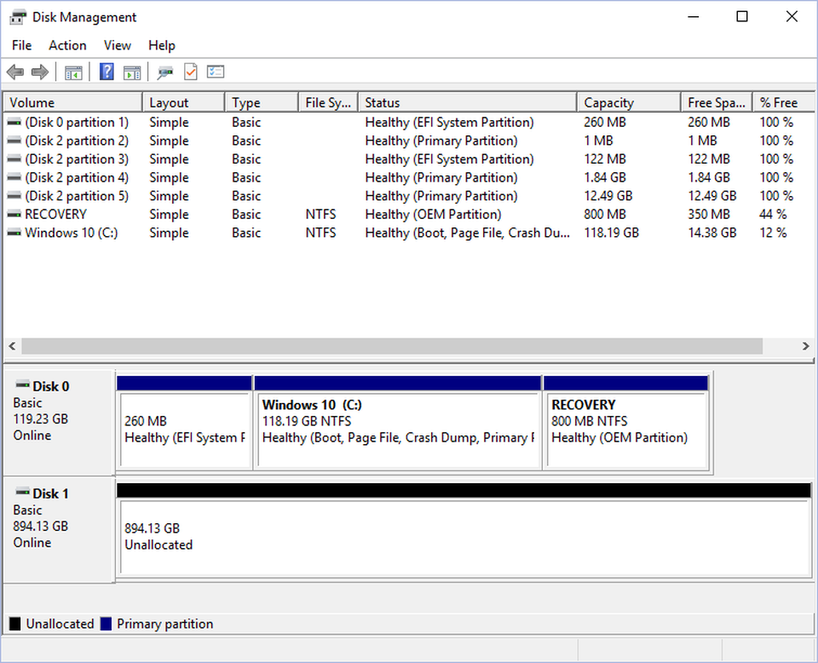

Windows 10 disk management tool. In my example I've devoted a spare drive to Ubuntu. It's not... [+]

 MICROSOFT

Because of the variables here, I can't give you specific instructions for each one. But to check out your current drive situation, click the Windows key (Start button) and type "disk management." This will show you the number of drives you have, and how they're partitioned.

**Step2 :Download Ubuntu in google chrome:**

Go to the google chrome , then type url bar “www. ubuntu 19.10 download” latest version downlode.

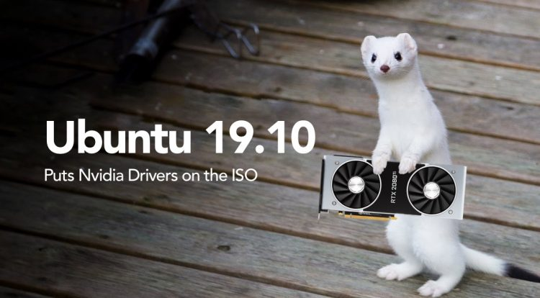

**PART 2: Ubuntu test drive and installation.**

You have a bootable Live USB, and your PC should boot from it. When you boot up your system again you should see a text menu with the options to try or install Ubuntu. For now, let's take it for a test drive. It's optional, but it will get you familiar with the layout and user interface, see if your WiFi adapter is detected and check if things like resolution and graphics cards are working properly.

Don't worry about messing anything up here. Have a look around, browse the Software Center and get to know the Settings menus. While you're in Settings you can connect to your Wireless network, connect Bluetooth devices and adjust your display options among many other things. If you set up "persistence" during the UNetbootin portion of this guide, you'll be able to reboot and have all your settings saved.

*Sidebar: Ubuntu ships with graphics drivers for AMD Radeon cards, and will automatically install a basic, open-source driver for your Nvidia GeForce card. For basic graphics acceleration you shouldn't need to do anything more out of the box. I'll get into more detail in the next guide which focuses on gaming (including playing some of your favorite Steam for Windows games!)*

**Step 1: Starting The Installation**

Ready to roll? If you're just booting up, select "Install Ubuntu." If you're taking a test drive, click the top-most icon the dock that says "Install" (it may be a shortcut on the desktop as well).

Installing Linux is so much easier than it used to be, so most of this will be straightforward. Just in case, I've tried to capture and represent each basic step.

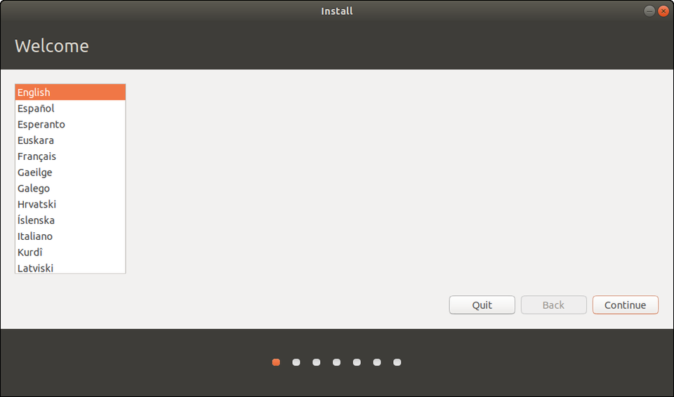

Select Language

 CANONICAL

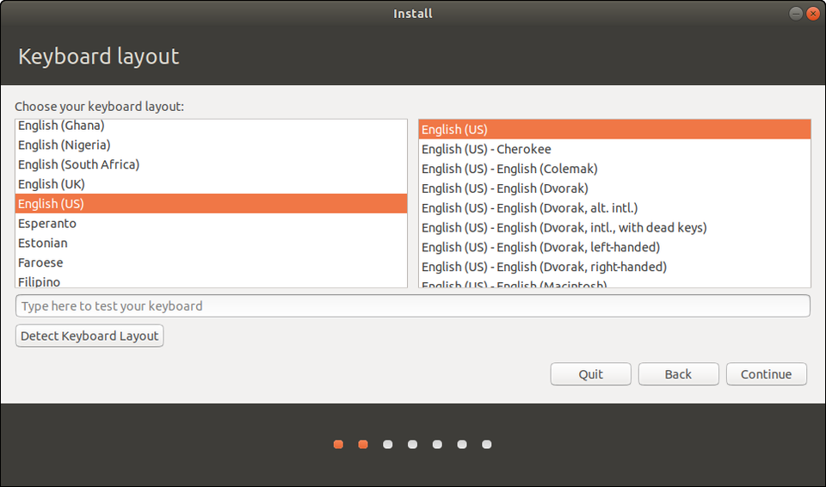

Select keyboard layout (you can add additional layouts at any time)

 CANONICAL

In the opening screens you'll choose your language and a keyboard layout, which you can change or add to at any time.

**Step 2: Get Connected**

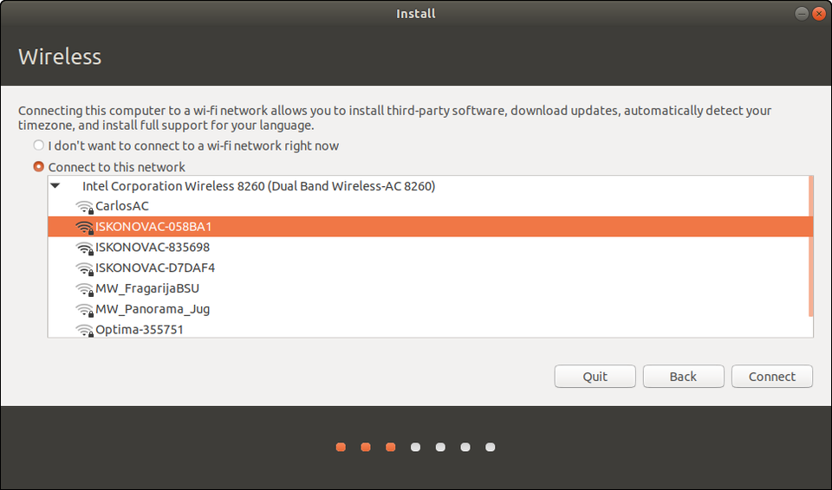

Get connected!

 CANONICAL

Then you'll connect to your wired or wireless network. A wired network (ethernet cable) will be automatically detected and initialized, but you'll need to choose your Wireless network name and enter a password. Getting connected now means you can download security and feature updates while Ubuntu is installing.

At its core, Linux supports a large number of wireless adapters and they're normally detected without issue. If yours isn't, you have many options after the installation, including using a Windows driver! It's a bit outside the scope of this guide, though. If you need help, [check here first](https://help.ubuntu.com/lts/installation-guide/i386/ch02s01.html). Then holler at [@AskUbuntu](http://twitter.com/askubuntu) on Twitter or explore [www.AskUbuntu.com](https://askubuntu.com/).

**Step 3: Updates & Other Software**

So far so good? Excellent! Now we're going to add a variable or two to the installation process. First, select "Normal" at the top for the fully featured experience. Most users coming from Windows aren't going to want a minimal installation.

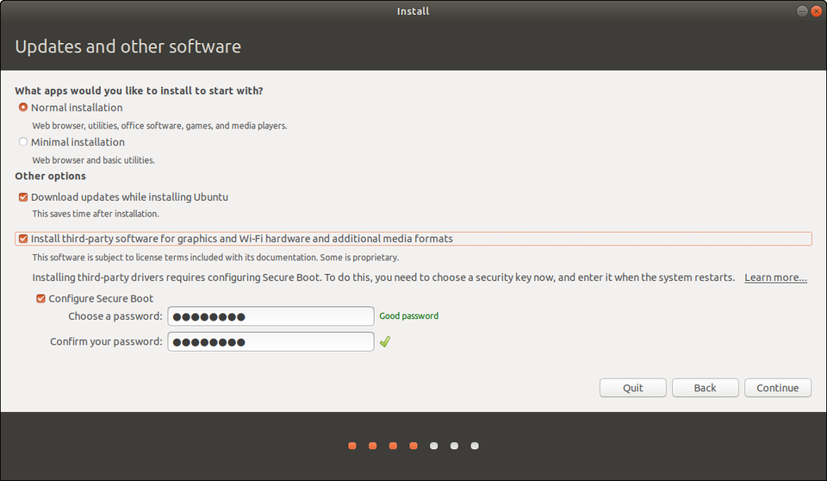

Additional installation options

 CANONICAL

If you have an internet connection check the box to download updates while installing. And definitely check the box that says "install 3rd-party software." This will open up options to activate optional Nvidia or AMD drivers, get you loaded up on media codecs for playing a wider range of music and video formats, and in general supply more hardware support out of the box.

Some PCs will have a Secure Boot option here. If so, Ubuntu will ask you for one-time password that you'll enter here, and then again when your system reboots. Don't worry, the OS will tell you when it's going to happen and instruct you what to press. It'll be during your first post-installation boot. As mentioned earlier, I do recommend disabling Secure Boot altogether in your BIOS.

*Sidebar: What is Secure Boot? It's basically a verification system that makes sure code launched by firmware is trustworthy. A lot of systems shipped with Windows on it have pre-loaded keys that indicate trusted hardware vendors and software providers. When you install some third-party drivers on Linux, Secure Boot will need to be turned off. To the best of knowledge these third-party drivers don't pose any risk, but it's a necessary step. If you're interested in learning more, check out*[*this Wiki*](https://wiki.ubuntu.com/UEFI/SecureBoot)*.*

**Step 4: Partition Magic**

Now the part that makes people nervous: where to install Ubuntu. Depending on your system's configuration, you'll be presented with a couple core options. Do you want to install Ubuntu alongside Windows, or erase a disk entirely for Ubuntu? (Remember that you if you choose to dual-boot Windows on a single disk, you can choose which OS to load during boot.)

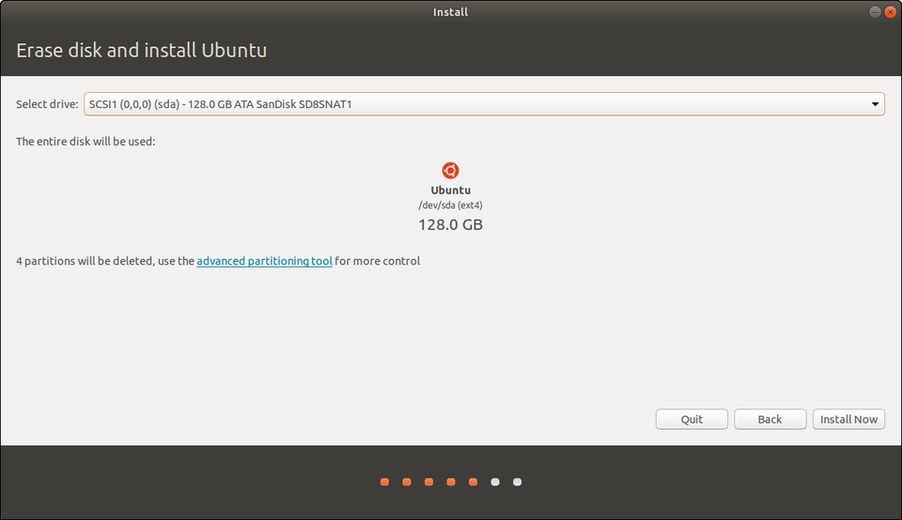

Want to erase a disk and have Ubuntu do the partitioning for you?

 CANONICAL

For erasing a disk, you'll get to choose which disk in the following screen. If you have that spare drive installed, just choose that and let Ubuntu do all the heavy lifting and auto-partitioning.

Now, both the above options are equivalent to pressing the easy button. Ubuntu will automatically partition your drive. If you're opting for either of the above, I'll see at Step 5!

"Something Else" is the exact opposite of easy.

"Something Else" means you don't want to install Ubuntu alongside Windows, and you don't want to erase that disk either. It means you have full control over your hard drive(s) here. You can delete your Windows install, resize partitions, erase everything on all disks. So proceed with caution. On the plus side all the changes you make won't be executed until you click Install. You can always go back or start over.

The example I'm going to use is a system with two drives. One has Windows on it, and I want to leave it untouched. The other is blank.

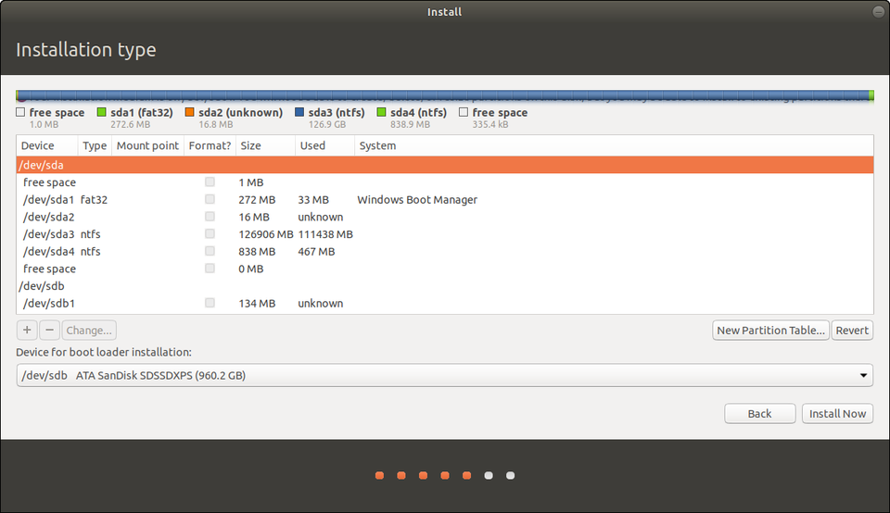

Partition Manager during Ubuntu setup. Be careful here.

 CANONICAL

The above example might make your eyes water, and I felt the same way the first few times. Are you SURE you don't want to just erase your disk and avoid all this? Just kidding! So what do all these letters and numbers mean? Time for a. . .

*Sidebar: Here's how Linux identifies devices. "****dev****" simply means "a device that you can read from or write to." Then we see "****sda, sda1, sda2****," etc. In Unix "sd" indicates a block device that can carry data. Then it identifies them alphabetically in the order they're discovered. Finally, the number (1, 2, 3) indicates the partitions. So /dev/sda1 simply means the first partition of the first drive.*

*Partitions? Think of them as slices of a pie. You can use one entire drive without doing anything to it. Or you can divide it into partitions -- logically but not physically separating them. One of my 2TB drives is divided into 1TB partitions. The 2nd partition is just for Steam game installations, so even if I reinstall an operating system, that part of the drive remains intact and loses no data. With Linux, partitions are necessary.*

Knowing that, you "Something Else" adventurers will need to add about 4 partitions to your extra drive. I'm going to take you through it step-by-step.

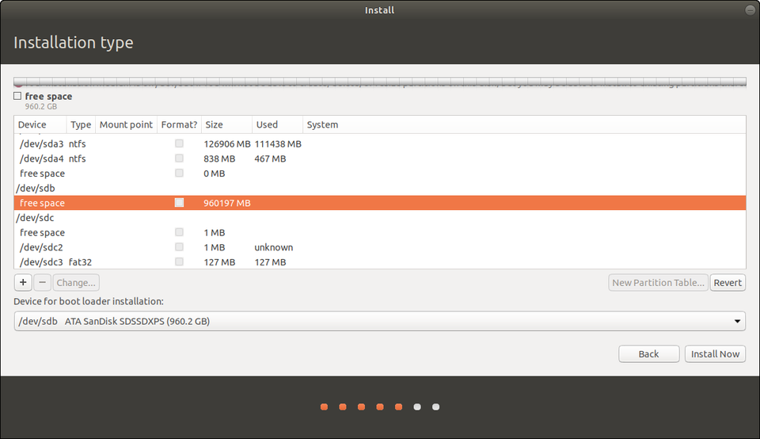

Identify the drive you want to install Ubuntu to

 CANONICAL

First, identify the drive you want to install Ubuntu to. I know that it's "sdb" because it lists 1TB of free space and there are no partitions. So, highlight yours (remember it will be the one that looks like "/dev/sdb"and then click "New Partition Table."

Now you will need to create 3 partitions, beginning with a "Swap Area."

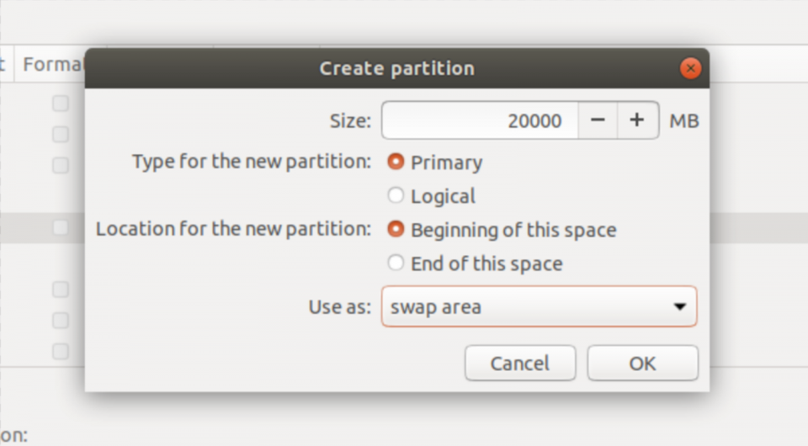

Create a "Swap Area" partition

 CANONICAL

Swap is a small space on the drive that is used like system memory (RAM). As a rule of thumb, you'll want it to be slightly larger than the amount of RAM you have in your PC. I have 16GB of RAM, so I'm creating a 20GB (or 20000MB) swap partition.

*Sidebar: You may be required to create an "EFI Partition" as well, and if so Ubuntu will tell you. The EFI partition is where the boot loader is installed and tells your PC which operating systems can be booted. Sometimes you can install it to your Windows drive, and you'll notice there's a drop-down menu to choose where that happens. If you're asked to create one, just follow the same procedure as all other partitions. Make it 250MB.*

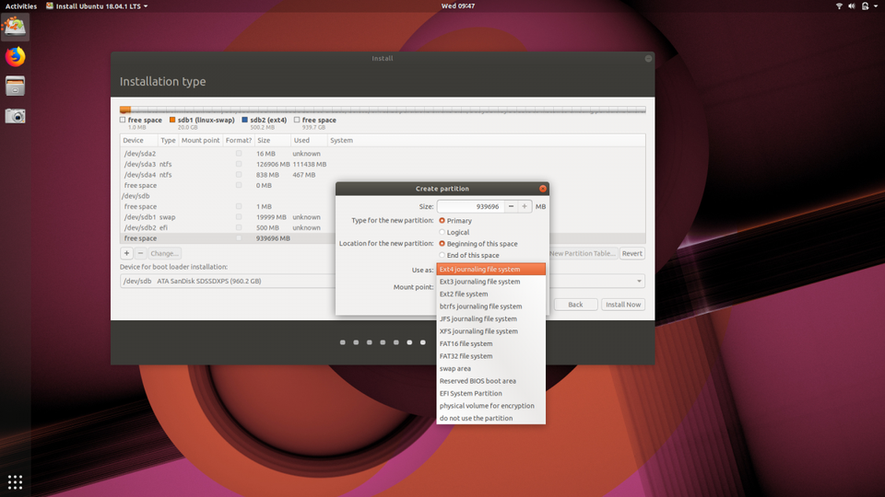

Create a Root partition with the EXT4 filesystem.

 CANONICAL

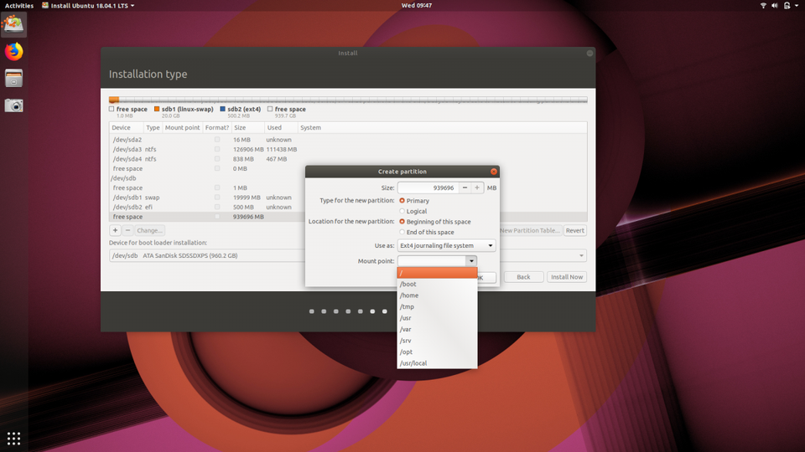

Then select "/" as the mount point.

 CANONICAL

Next let's create our "root" partition using the Ext4 filesystem. (Fun fact: the Ext4 filesystem supports volumes up to 1,152,921,504 GB!) The root partition is the top-most directory of the drive and Linux won't work without it.

For its size, you can use the remaining space on your drive which should be automatically inserted. Some will argue that a "/home" partition should also be created (think of /home as the account directory in a Windows installation like "C:/Users/iqbal." But Ubuntu will automatically create a "home" folder for your documents, photos, videos and other media and files. It's very easy to back up or transfer to another Ubuntu installation, so I choose to use only the Swap and Root partitions. (As a relative beginner I'm happy to have my mind changed!)

You've told Ubuntu setup how to partition your drive, and when you click "Install" those instructions will get executed. First you'll get a confirmation of the changes. If you're happy with them, make it so!

**Step 5: Your Region & Account Info**

The hard part is over, and I hope it went smoothly for you. All that remains is choosing your region and creating a username and strong password. Because I'm lazy, I usually choose to log in automatically.

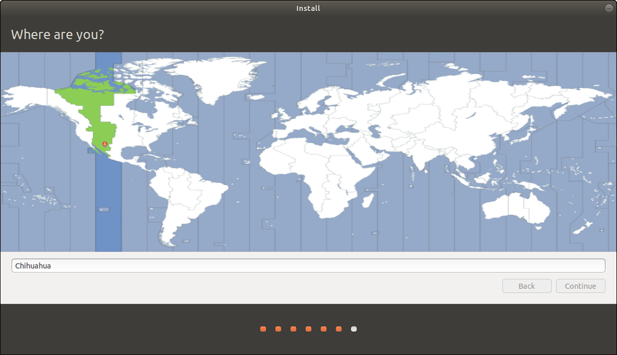

Choose your location!

 CANONICAL

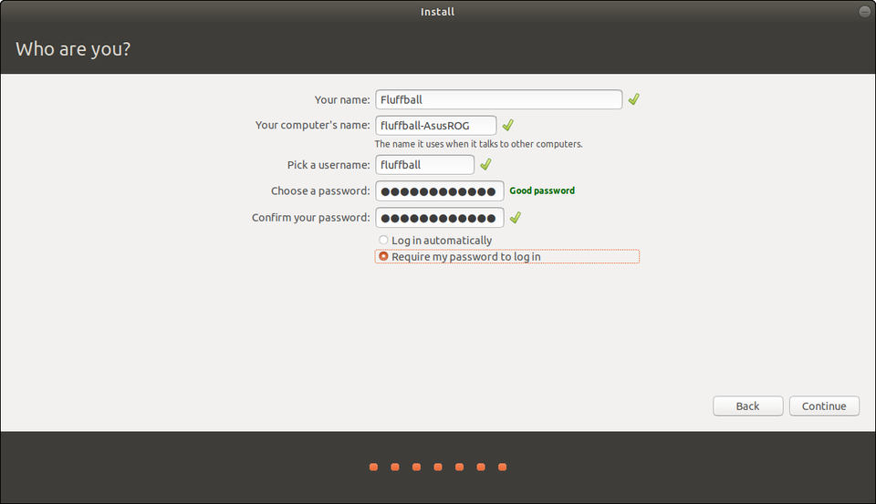

Create a username and a strong password. Optionally, choose to log in automatically.

 CANONICAL

**Step 6: Grab A (Small) Cup Of Coffee**

Now Ubuntu will start installing and downloading any additional packages if you chose to grab updates. But wait, why a small cup of coffee? Because it's fast. Really fast. On my Dell XPS 13 with a USB 3.0 stick and an NVMe drive, it took less than 4 minutes. Even on older hardware it's really snappy.

**Step 7: Enjoy Ubuntu**

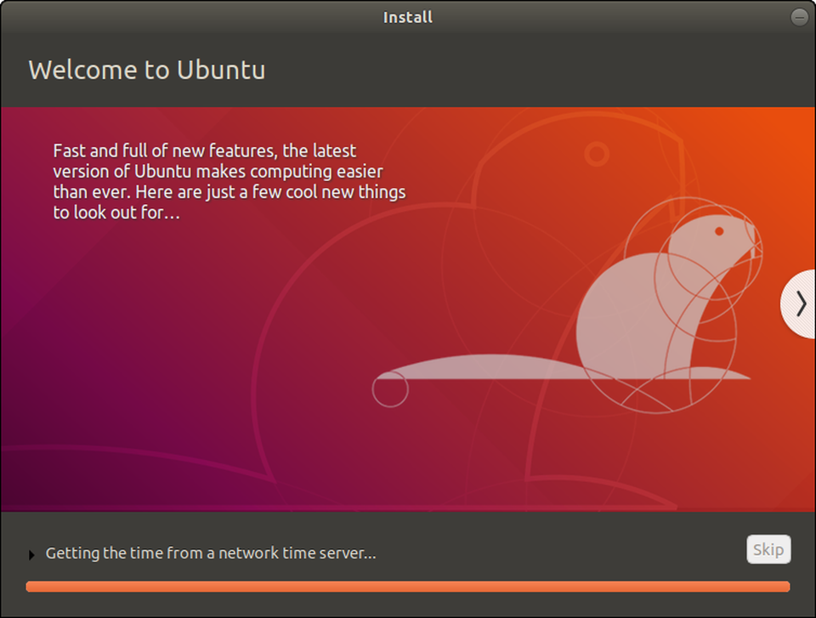

Ubuntu installation

 CANONICAL

You should be prompted to remove your installation media and reboot. If you had to do the secure boot option, you'll be taken to that screen and your password will be requested.

For me, the installation process was just a first small step in a longer and much more exciting journey. Hopefully yours is headache free, productive, and fun! Explore the [Snap store](https://snapcraft.io/store) to install popular apps like Spotify, Skype, Discord and Telegram in a single click, or check out the wealth of open source software available.

Ready to start gaming? [Check out my beginner's guide](https://www.forbes.com/sites/jasonevangelho/2018/08/30/ubuntu-guide-how-to-install-nvidia-drivers-and-play-windows-games-on-linux/) to updating your graphics drivers and playing Windows-only games on Steam for Linux!